Dynatrace setup in the Kubernetes cluster

Create the necessary objects for OneAgent Operator.

kubectl apply -f https://github.com/Dynatrace/dynatrace-oneagent-operator/releases/latest/download/kubernetes.yaml  
  
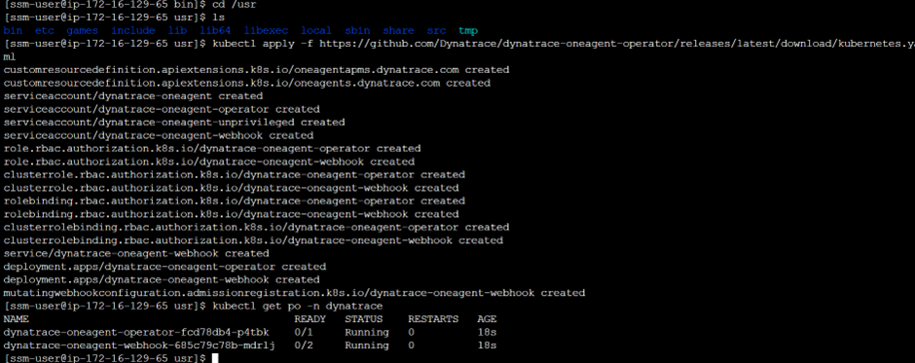  
  
**Generation of token**

**We can see Host details in the Dynatrace application.**

**Active gate installation:**

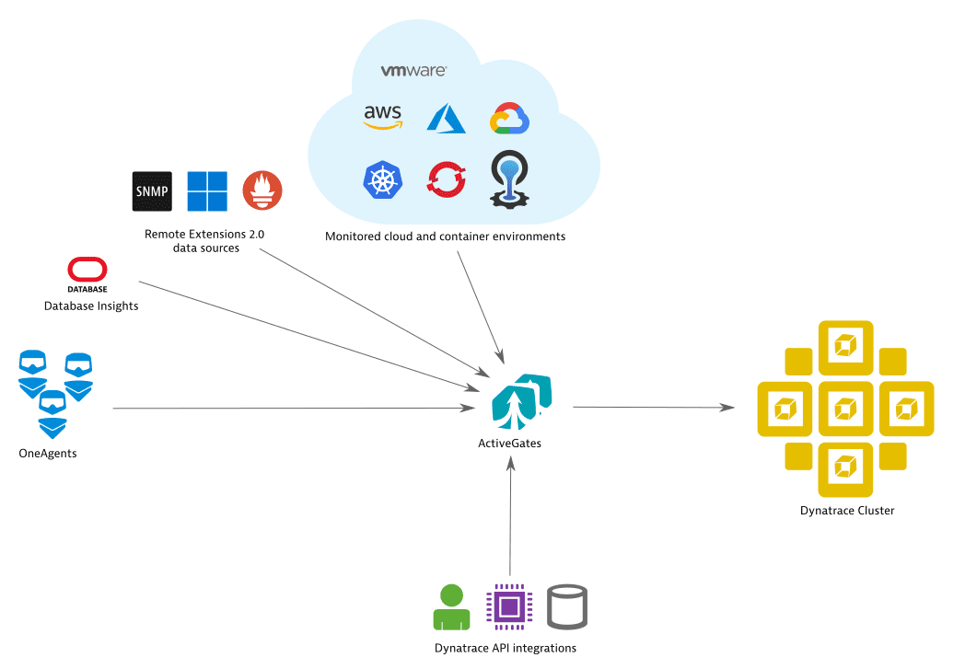 **Get the dynakube.yaml file from the Dynatrace and run.**

 **Kindly follow below link for more information :**  
https://www.dynatrace.com/support/help/setup-and-configuration **Dynatrace dashboards:  
Kubernetes cluster dashboard:**

**Problems dashboard**

